Computer Architectures Workshop 4

# Combinatorial Circuits

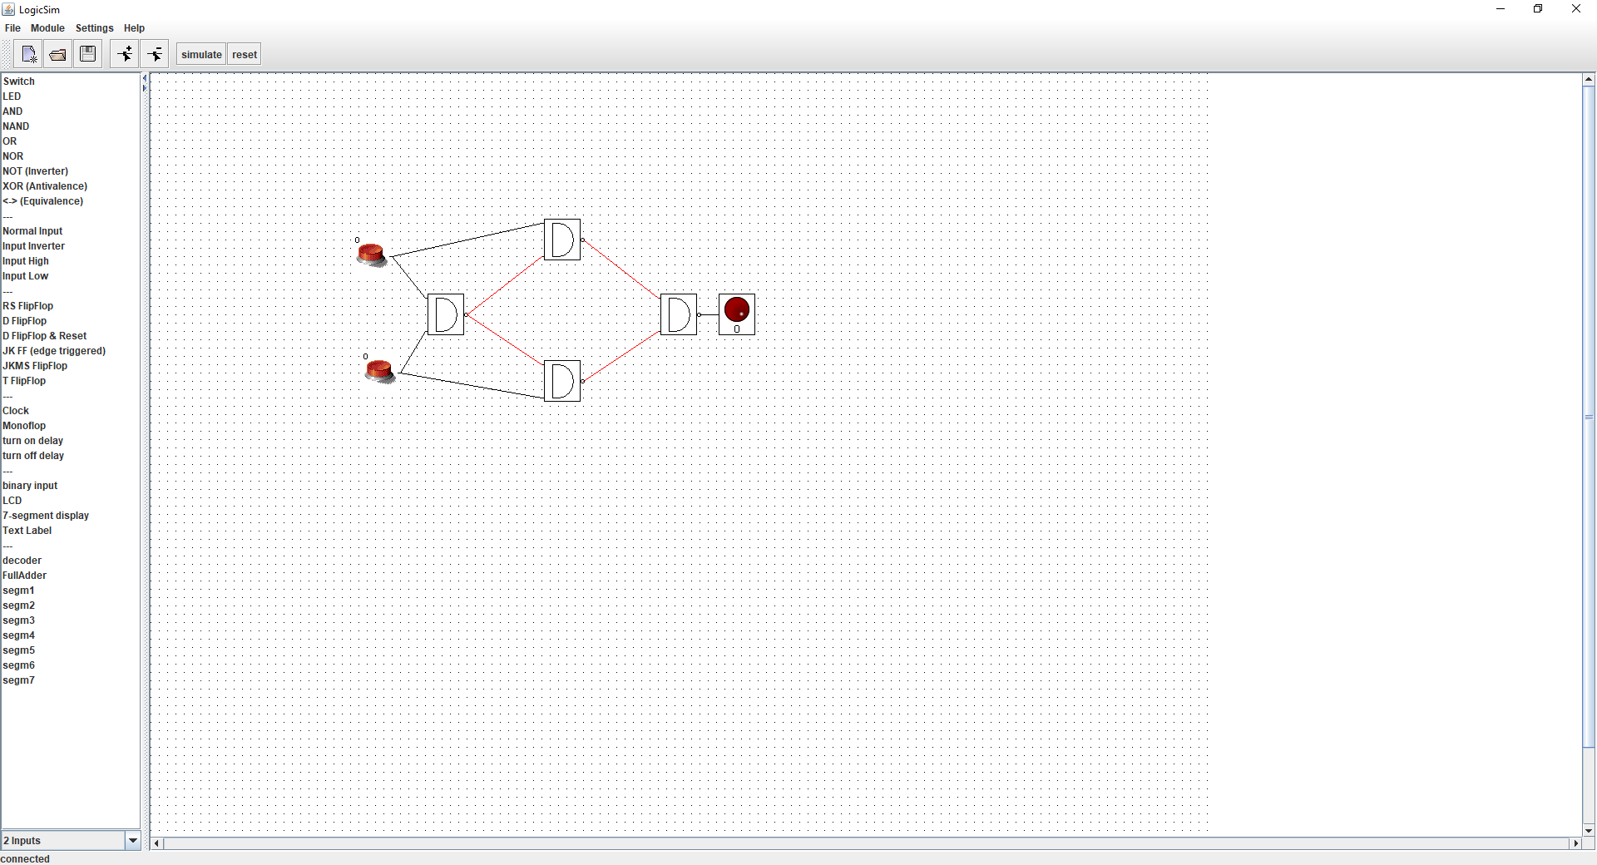

XOR gate made with NAND gates.

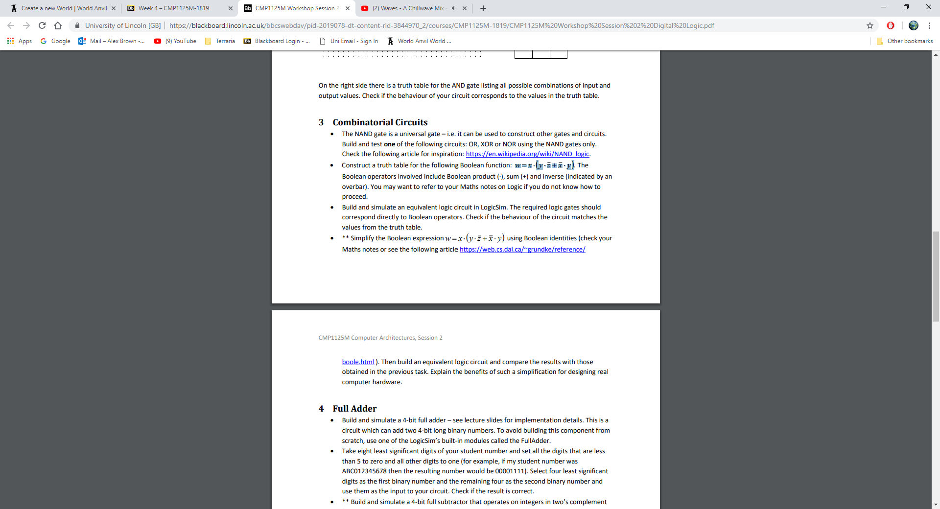

Truth table for:

|  |  |  |  |
| --- | --- | --- | --- |
| x | y | z | w |
| 0 | 0 | 0 | 0 |
| 0 | 0 | 1 | 0 |
| 0 | 1 | 0 | 0 |
| 0 | 1 | 1 | 0 |
| 1 | 0 | 0 | 0 |
| 1 | 0 | 1 | 0 |
| 1 | 1 | 0 | 1 |
| 1 | 1 | 1 | 0 |

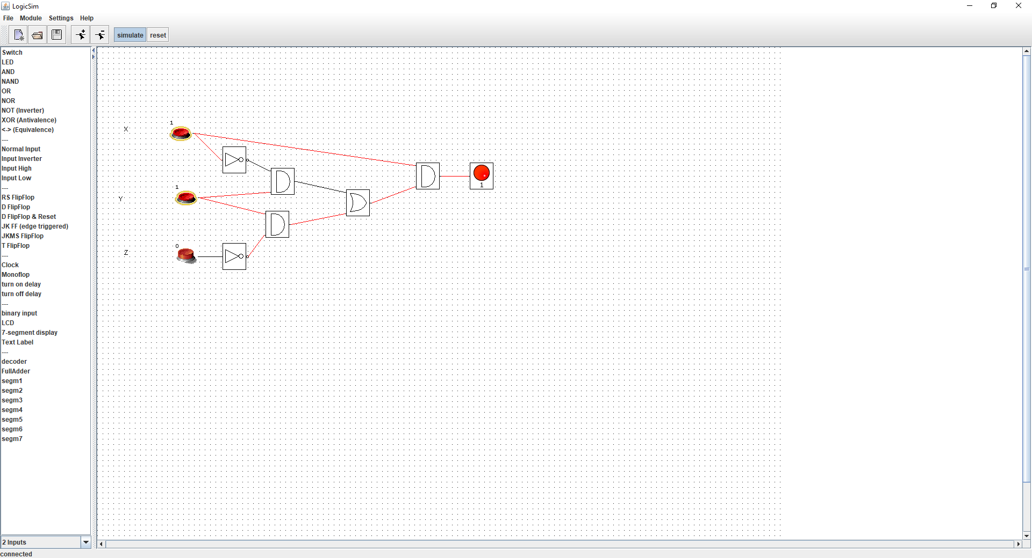

Simplify

* w=x.y.¬z

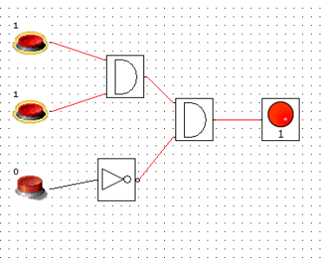

Simplifying the design removes unnecessary logic gates and reduces the amount of checks required for each input.

Student number 16653219 🡪 01110001

0111 + 0001 = 1000

|  |  |  |  |
| --- | --- | --- | --- |
| Nr | Qt | Action | Qt+1 (After the action) |
| 1 | 0 | S button pressed once | 1 |
| 2 | 1 | R button pressed once | 0 |
| 3 | 1 | S button pressed once | 1 |
| 4 | 0 | R button pressed once | 0 |
| 5 | 0 | S button pressed twice | 1 |
| 6 | 1 | R button pressed 3 times | 0 |
| 7 | 0 | S button pressed and released, then R button pressed | 0 |
| 8 | 1 | S and R button are pressed simultaneously | 0 |